Ideation Phase Brainstorm&Idea Prioritization

|  |  |
| --- | --- |
| Date | 20 September 2022 |
| Team ID | PNT2022TMID12796 |
| Project Name | INDUSTRY-SPECIFIC INTELLIGENT FIRE MANAGEMENT SYSTEM |
| Maximum Marks | 4 Marks |

Brainstorm & Idea Prioritization :

Step-1: Team Gathering, Collaboration and Select the Problem Statement

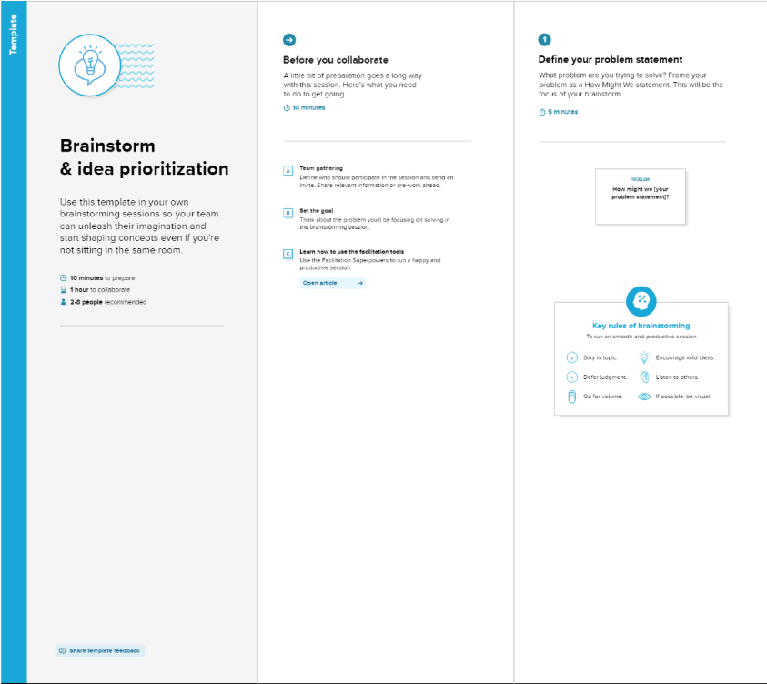

**Step-2: Brainstorm, Idea Listing and Grouping**